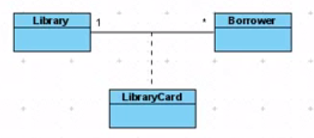**Association**: relation between classes

**Association class**: an intermediate class which describes the relation between two classes.

**Aggregation**: Musician is part of band

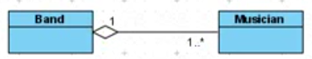

A musician can be part of multiple bands 🡪 sharing is enabled.

**Composition**: no sharing e.g. room is part of a building.

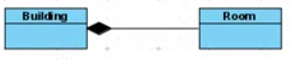

**Generalization**: Relationship between a general class to a more specific class

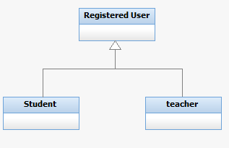

**Realization**: It does not have any implementation and is “realized” by another class. Pure virtual Classes or templates. Stereotype should be <<interface>>.

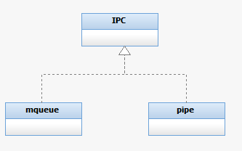

**Dependency**: client uses a supplier

